Images of our 2017 September Visit at Bear Spring Camps, Belgrade Lakes, Maine

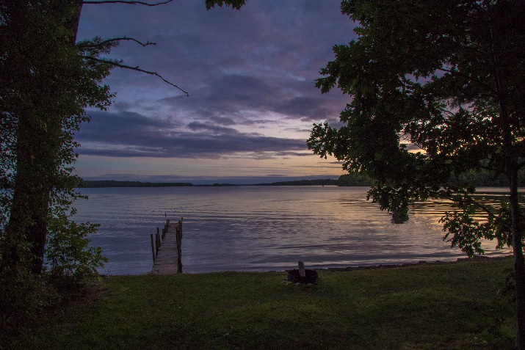This is a photo album of our Fall stay at Bear Spring Camps, Belgrade, Maine. Our thirtheen Fall holiday brought 13 days of excellent kayaking and five days of really nice swimming in clear waters. This album includes various photos of us kayaking and doing this and that while absorbing the wildlife and tranquality. A lot of activities over the 14 days resulted in a photo or two.

Note that the wildlife, modulo the woordpecker, and spiderwebs, were taken from our moving kayaks. The photo opportunities were often and excellent as was the dining room food and our accodomations.

And for the photos, click [Bear Spring Camps, ME, - September 2017.](https://photos.app.goo.gl/6WnSN6gf2ibb8WP82) You are encouraged to “Zoom”. Don’t miss the Big Dipper over the Dining Lodge and the double star in its handle. Then there is the moon in the daytime…